

Weekly Update – Drivers Alliance News
Are cars being unjustly treated?

“Electric cars will speed climate change” claims a report from the Environmental Transport Association (ETA)1.
This sounds bizarre; but it seems the report’s intended target is Governments energy policy and how we generate future electricity rather than the uptake of electric vehicles.
Using the car to lobby governments on energy policy typifies the often fallacious thinking about the environmental aspect of personal transport. If the uptake of electric cars would cause an increase in CO2 emissions then surely the electrification of the railways would be just as culpable? So why choose to put the car under the spotlight? Is this another example of the double standards applied to the different modes of transport?
Organisations like the Campaign for Better Transport petition for a halt to all road building claiming that ‘predict and provide’ doesn’t work. But in response to our recent report on the disparity between road and rail spending, they call for increased investment in rail to meet future increases in demand from rail passengers. Rail lobby group Greenguage21 called road building ‘a mugs game’ while again repeating the call for investment in rail to meet predicted future demand. It seems ‘predict and provide’ is OK for public transport but ‘demand management’ is the order of the day for our roads.
The government is also busy working to reduce speed limits (to reduce CO2). Which will increase journey times whilst at the same time proposing a £32bn investment in High Speed rail, claiming it: “…would mean shorter journey times, improved reliability, accessibility and greater capacity and all this, most importantly, would have a dramatic effect on the nation’s economic output”
If increasing the speed of trains can have a “dramatic effect on the nation’s economic output” then surely lowering the speed limits on our roads with the resulting longer journey times will have a much more dramatic effect on economic output as the vast majority of economically productive journeys are made by road.
Whilst drivers more than cover the cost of their CO2 emissions through motoring taxes, public transport passengers are effectively subsidised by the government for their emissions.
Technological innovations will continue to improve the efficiency of the motor car which will soon result in passenger emissions equalling or bettering that of the various public transport modes.
How then will public transport companies and their lobby groups such as the CfBT make the case for massive taxpayer investment in buses and trains when over 90% of journeys are made by car? Indeed, a recent report into the government’s high speed rail proposals reveals that the private car is actually lower in CO2 emissions than the proposed railway.

Continued …
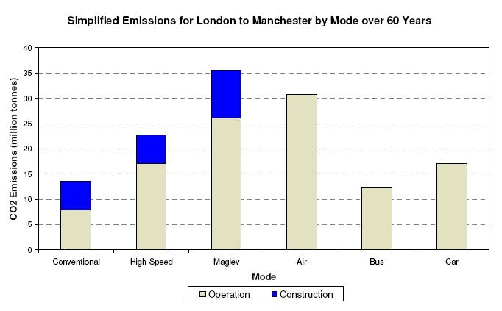

The PPP comments… The DA do a good job reporting on these issues and we generally endorse their realistic appraisal. We repeat again that the ‘War on the Motorist’ uses the Police and the abusive ‘speed kills’ road safety policy to progress the agenda of the deranged minority who believe in the ‘new religion’ of global warming. The majority fearfully follow their lead. The believers have no real understanding of economics or climate change and will pursue their cause relentlessly until the roads gridlock, the lights go out and we all die of starvation or hypothermia. The above chart can be read as comparative fuel costs based on current fuel/energy sources. New Nuclear electric power will dramatically change the picture in terms of CO2.

